
http://www.clinecta.com

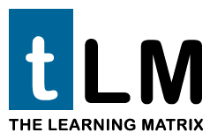

Revolutionizing Distance Learning with The Learning Matrix

About Clinecta
Clinecta was formed to help serve the global and universal need to enhance education. The founders of Clinecta bring with them many years of consulting, management, and training experience in the information technology industry. We are a software and professional services firm specializing in providing education enhancement tools and methodologies to traditional and corporate education.

Our guiding principle is to build and integrate educational tools that will empower instructors, students, and administrators. Thereby creating an atmosphere of focused instruction and learning reducing administrative and logistical burdens.

Our main objective is to evolve education delivery by building and implementing modular and integrated tools that enhance education by:

- Improving learning and comprehension
- Enabling more focused teaching and learning
- Automating routine administrative tasks
- Assist in providing web-based access to traditional instruction and lectures
- Reducing development, delivery, and travel costs
- Capturing statistics such as data cost, utilization, and effectiveness
- Minimize future course development time
- Reducing the costs of upgrading and modifying courses
- Enabling self directed learning
- Increase instructor availability for focused teaching as needed or desired
- Elimination of physical space constraints and conflicts

Introduction
When we designed The Learning Matrix (tLM), we started by studying how people learn, how well they retain information, and how long they are able to focus their attention while learning. We determined very early on that people, on the whole, are best able to focus their attention in segments of 15 minutes. In fact, we decided to build an entirely new learning system, from the ground up, using this knowledge.
A system that contains multiple short segments allows people to take advantage of their natural learning ability. It is difficult for people to learn when forced to drink knowledge from a proverbial “fire hose.” After 10 or 15 minutes of learning, the ability to retain information begins to drop off dramatically. A system that uses properly segmented content, or modules, allows people to not only work at their own pace, but they can review each “segment” as many times as is necessary to achieve optimal retention, understanding, and mastery.


Using The Learning Matrix to create a course in Basic Algebra, Clinecta consultants, working with our clients, incorporate the courseware already in existence by breaking down the content into logical or conceptual components; addition, subtraction, multiplication and division. These components are indexed and stored in The Learning Matrix’s repository with all prerequisite relationships defined. When building the class the instructor need only pull together the proper sections and add the new segments that comprise “algebra”. The Learning Matrix takes care of the rest. If a segment’s content changes over time, only segments directly affected need to be adjusted. An entire class no longer must be discarded when one or more components change.

Thus, The Learning Matrix creates a framework that integrates software, methodology, and content management into a structure that provides a web-based, modular educational delivery system from a learner centric perspective. It organizes, indexes, and stores all the data that comprises a course and it presents this information using the Internet; making possible 24x7, on-demand, learning and performance tracking. The Matrix simulates a traditional classroom, but through use of multi-media technology it delivers education in a more flexible and enhanced manner.

Distance Learning

Many LMS (Learning Management System) systems have provided a static and linear approach to educational content delivery. Much time has been spent on the authoring, administrative, community, or portal based functions of the traditional LMS. Little or no effort has been paid to student skills assessment and performance evaluation. When combined with a predictive and active course delivery mechanism, this can dramatically increase and enhance not only student performance, but curriculum performance as well.

The Learning Matrix can be used in a proactive manner to ensure all students are prepared prior to participation in class, lecture, or laboratories. Not only can The Learning Matrix stand alone as an efficient and effective means of educational delivery, it can also help to fill the classrooms with prepared and qualified students, leaving the instructor or professor to concentrate on the course materials, lecture, or laboratories. The Learning Matrix will provide the instructor more time for individual and interpersonal interaction with the students and help them mange the needs not only of gifted learners, but learners in need of remediation.

Educational Performance Measurement
One of the aspects that we found most startling about traditional Learning Management Systems is that they do not provide a system of accurate performance measurement. Most of them provide mechanisms for quizzing and testing in a variety of ways however; they do not use the student performance data that can be collected. They simply store the data and report it to the student, instructor, or the course designer.

The Learning Matrix differs significantly in the way in which it provides many new concepts and mechanisms for performance measurement. Not simply performance measurement of student performance but measurement of the instructor performance and even departmental and organizational performance.

By indexing questions along with the conceptual segments, a series of pre-tests and post-tests can be delivered that manage learning, and statistics related to learning, at the most granular level possible.

The 80/20 Rule
According to the Pareto Principle, "A minority of input produces the majority of results." For example, 20% of your products or services will account for 80% of your profits. In the case of education and training 20% of your teaching efforts often produce 80% of your results. Additionally, 80% of your students will complete any educational requirements without major difficulty, leaving 20% of your students to either fail or master the course material in an exceptional manner.

The Learning Matrix, for the first time, can accelerate those 10% of students that are able to perform above the normal level. The Learning Matrix can also accommodate those 10% of students that fall below acceptable performance levels and help them to achieve at least what the remaining 80% of their classmates can or hopefully even propel them into the other 10% of students that are far above the average.

Content Effectiveness Management
Beyond end-of-course student evaluations, the instructor, staff, and administration have no way of measuring course quality and effectiveness.

Today when education is delivered, it may take weeks or even months to understand if the content is understood by a broad group of students. Once a negative trend is discovered, the only way to determine if the problem is with the course content is to ask the students. Furthermore, the students may not truly understand the root cause of the problem themselves or may have personal biases with their educational experience. In addition, differences in delivery styles may be a significant factor. If the problem is with a particular curriculum area, additional time is spent in understanding the nature and the source shortcoming. Currently most of this evaluation is done by hand and by word of mouth, if it is done at all. Many times the results and the necessary changes are difficult to identify. This often leads to non-existent or poorly implemented solutions.

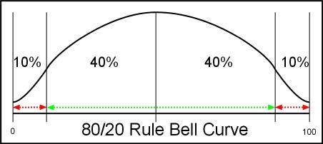

By using an automated system to deliver standard content, it is easy to track the performance of an individual content unit (15 minute segment) or the entire curriculum. If 100 students progress through 100 units of learning content and fall within an acceptable or normal performance bell curve, any units where the students under perform will be identified very quickly. Those individual units can then be analyzed for clarity and proper placement relative to the other segments and their pre-requisites. Then, a fact-based decision can be made to move or rework the segment. Once the segment is re-worked, it can be released on a limited or pilot basis to test the fix or placement before being implemented globally.

Educational Enhancement
The Learning Matrix is delivered within a single user interface consisting of sound, graphics, and video. This interface resides and interacts with your existing LMS server or upon ours. Your educational and training content is presented through the use of Macromedia Flash™ Player, a small, lightweight technology that is universally accessible (98 percent of Web browsers already have Flash Player installed). Because Flash sends information in the same manner as standard Web pages, it is not blocked by corporate firewalls, which frequently block the content of other rich-media formats.

Traditional distance learning has essentially evolved from correspondence courses to video taped lectures with accompanying written material and books to the eLearning platforms that organizations are currently migrating to and implementing. The Learning Matrix incorporates the traditional correspondence, video and print lecture with today’s emerging eLearning platforms and LMS systems. All of this functionality and tradition, combined with the focus on performance measurement, intricate testing and effectiveness polling, and extensive reporting mechanisms distinguish The Learning Matrix as unique among its competitors. Our technology has proven unique enough to warrant the granting of a patent application from the US Patent Office.
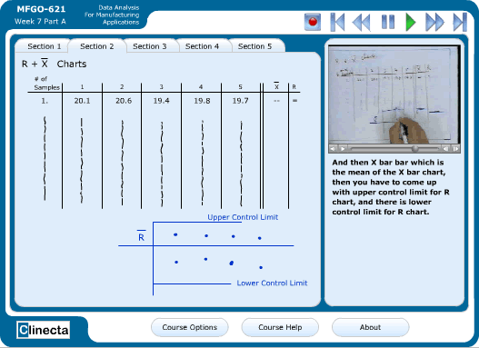
The Learning Matrix

Rich Media
Audio, text, video, and interactive presentation are the key elements in rich media learning. The Learning Matrix expands this concept beyond the current thinking about rich media.
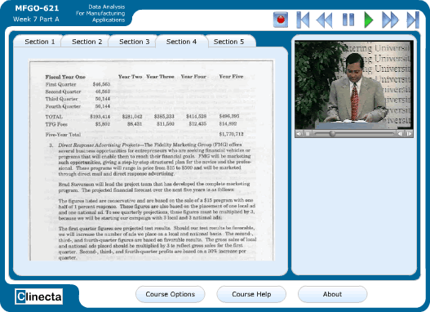
The Learning Matrix

The “ilities” For Standards Compliance

Interoperability

Portability

Reusability

Flexibility

Accessibility

Compliance and standards are crucial to Clinecta and have been carefully thought out in The Learning Matrix from its early stages of development. Our own internal organization has carefully adhered to ISO standards as well as many others. Education standards such as AIC and SCORM compliance have helped to guide our development methodology.

Audience: Education
Applications:
- Universities and Colleges With Existing LMS Systems
- Universities and Colleges Without LMS Systems

- Virtual Universities and Colleges
Many colleges, universities, and K-12 institutions have already chosen a distance-learning model and begun to implement an LMS. Clinecta has worked extensively with many of the major software companies that produce learning management systems to ensure interoperability with them.

Clinecta’s intent is not to replace any of the LMS already paid for and in place. To this end, Clinecta is building API’s, which will work with current systems to augment them and provide the institution with a level of granularity, control and sharing of educational content unavailable in any current LMS offered today.

Educational institutions can use The Learning Matrix as both a content management and delivery system or as a tool to measure and prepare students prior to attending traditional classrooms. By using tLM to prepare students before they attend classes, educators will have greater certainty that their students have come to class with a consistent level of baseline knowledge that is necessary for them to succeed in their class. Less time can be spent bringing students up to speed, more time on covering the knowledge and information for which the class was intended.

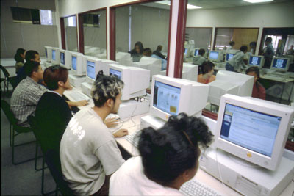
Intellectual Property (IP) is a valuable and precious contribution that needs to be protected and honored. A feature that The Learning Matrix has taken great pains to record and manage is ownership of the intellectual property inherent in the conceptual segments. Every instructor is invited to participate in the recording or production of the segments they own. What could prove ownership better than having your name and face on it? Beyond that, tLM indexes the IP ownership identification along with the segment. Every time a student access a segment, this ‘click’ can be recorded and segments scored for usage. Everyone gets credit for the intellectual property they have worked to provide.
Audience: Business
Applications:
- Corporate Training Programs
- Regulatory Compliance Training
- Certification and Maintenance Training Programs
- Customer Training and Product Support Training
- Human Resources and Employee Orientation Training

Education and certification standardization have been both the goal and, in many regards, a great source of pain and frustration for many businesses. Maintaining certifications in various skills, practices and corporate level certifications has become more complex, expensive, and mandatory in many cases. Often, it is considered a counter-productive requirement, given the deficiencies of the training delivery systems available today.

The Learning Matrix is able to hold libraries of optimized educational content that are segmented and indexed at the concept level. It supports delivery that appeals to multiple senses: audio, video, and interactive. The Learning Matrix also houses questions linked to that educational content within its repository. Knowledge providers and education managers can tie previously populated content together with their related questions to quickly create an entire course or a series of certifications (both training and testing) that can be made available to all members of a dispersed global organization.

In addition to taking advantage of people’s natural ability to retain knowledge in small doses, standardized sets of training segments will alleviate the differences in delivered and retained knowledge that frequently occurs with today’s methods of dissemination throughout a global organization.

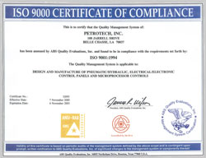
A common method of delivering training and certifications begins with a “Super Trainer” delivering a certification class to a secondary group of trainers (Train-the-Trainer). This, by its very nature, ensures that there are now different versions of the classes as each individual incorporates personal preferences and emphasis. As the class and certification spreads globally, the changes grow and expand; the content delivered will vary widely from class to class and with the physical and mental preparedness of each trainer. Standardized testing can only guarantee a certain amount of retention.

With this Train-the-Trainer process there is currently no guarantee of consistency of delivery from class to class. Engineers from across the globe could, with the Train-the-Trainer method; achieve the same level of certification and participate in the design (US), fabrication (Europe) and assembly (Mexico) of a specific item. The reality however is they could have similar, but slightly different understandings of the standard all three must implement. That might not be noticed until the part arrives at the factory in Mexico where it is then discovered that it is made of the wrong material or built to the wrong tolerance. If the engineers in all three countries have received exactly the same educational input, the chance that this mistake happens is greatly reduced.

By using electronic educational content the quality of the delivery can be guaranteed time and time again. It can be documented that all members of an organization have seen the same content. This can guarantee a level of shared exposure, unity of vision and direction in application of a standard or certification.

Key Features and Advantages

Multi-Media Modules
Effectively choreograph audio-video, presentations, overheads, content scripting/notes and pre and post tests/examinations into web-based learning modules/segments that simulate yet enhance real time education

Self-Paced Virtual Learning and Performance Management Anywhere, Anytime
- Access 24/7 learning via the Internet or Intranet
- Ensures that learning performance information is secure, allowing only the assigned managers and learners to view information
- Develop and use Individual Learning Plans to meet individual needs and requirements

Instructors
- Plan, create, edit and modify courses, content, requirements and lessons in a modular format
- Launch, track and monitor content effectiveness real time
- Launch, track and monitor (individual and group) progress real time
- Incorporate multi-media options increasing learner interest and retention
- Incorporate web-based certifications, assessments and examinations
- Monitor learner performance – individual and entire classes for trend analysis

Learning Managers/Administrators
- Organize and manage knowledge and learning by jobs, roles, and course catalogs
- Effectively track, measure, and maintain training records and learner progress
- Enable electronic signatures for effective and efficient approval
- Optimize resources and return on investment
- Deliver and manage resources, offerings, and collaborative learning environments via one system

Advanced Scalability and Connectivity
- Globally enable thousands of users
- Deliver and manage learning to large corporations and universities
- Integrate web-based collaboration tools to enhance the learning process and experience
- Integrate other data systems to enhance access and performance tracking/history

Automated E-mail Notification
- Notifications of re-certifications to be completed to meet compliance requirements
- Reminder notification of upcoming courses
- Notification of required courses past due
- Notification of completed and incomplete training
- Notifications of course registration
- Notifications of required classes or courses
- Notifications of revisions to required courses or documents

Extensive Reporting
- Integrated database tracks and records access and performance measurements for analysis, decision making, and compliance reporting
- Report organizational learning progress using extensive built-in reports
- Report on electronically signed mandatory documents to verify compliance for FDA, ISO, and other regulatory bodies
- Easily create detailed custom reports
Professional Services
- Installation and Configuration
- Training
- Technical Support
- Consulting, Custom Development, and System Integration

Installation and Configuration

The Learning Matrix Project Managers will coordinate with your IT staff, our Software Engineers and our Implementation Specialists to deliver your Learning Matrix implementation in a professional, efficient, and effective manner. Clinecta Technical Support Agents can provide additional offsite installation support.

Training
Clinecta is an educational industry innovator with our Meeting Matrix communications delivery methodologies. Clinecta can provide extensive online virtual classroom training, demonstration, and documentation.

Technical Support
Clinecta will provide extensive documentation for The Learning Matrix end-users, administrators, and managers. We can provide a traditional tiered support structure and we can also support our products using the Meeting Matrix itself for instant troubleshooting and problem resolution.

Consulting, Custom Development, and System Integration
The Learning Matrix development team and our Software Engineers can provide extensive integration with existing systems. On a per project basis, we will assist you in co-branding The Learning Matrix, sharing Learning Matrix data with other applications, and building customized Learning Matrix features for your organization. These assets will help you to design the best model of The Learning Matrix for your organization and allow you to fully guide its usefulness, integration, and plan for future enterprise expansion.
Hardware and Operating System Requirements and Specifications

The Learning Matrix Server Specifications

- Operating System: Windows 2000 Server, Windows 2000 Advanced Server or, Redhat Linux
- Processor: 2.0 GHz Pentium 4 (Pentium 4 Xeon and multi-processor configurations are available)
- Memory: 1-4 GB RAM
- Display: 800 x 600 VGA graphics (console switchbox ready)
- Network Adapter: Ethernet adapter (single and dual adapters are available)
- Web Server: Internet Information Server (IIS) 5.0
- Web Browser: Internet Explorer 5.5, Netscape 7.0 or, Mozilla 1.0 or greater
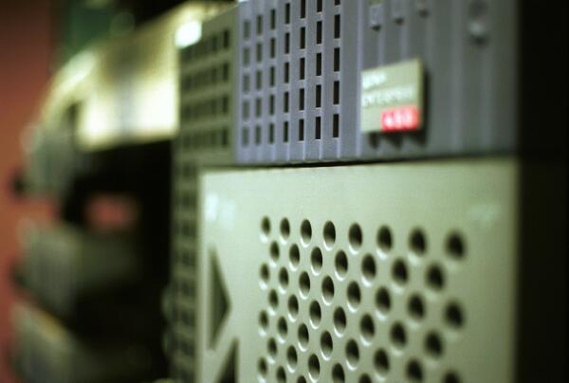
- Network Connection: DSL or greater broadband connection
- Database: Oracle or, SQL Server
- Sessions: 2,000 per server. Servers can be clustered for more capacity.

The Learning Matrix Student Platform

- Operating System: Windows/Mac/Unix-Linux
- Processor: 400 MHz Pentium II or, greater
- Memory: 64 MB RAM
- Display: 800 x 600 VGA graphics or, greater
- Sound: SoundBlaster or equivalent sound card
- Network Adapter: Ethernet or Modem adapter
- Web Browser: Internet Explorer 6.0, Netscape 7.0 or, Mozilla 1.3 or greater
- Network Connection: DSL or greater broadband connection
- Optional Video Camera: USB or parallel port Web camera
- Optional Voice: Web Camera (built-in) Microphone, headphone, or external microphone

The content, original images, and their arrangement herein are protected and owned by Clinecta, LLC. All rights are reserved. The Learning Matrix is Patent Pending. Macromedia, Oracle, Microsoft, Netscape, etc. are trademarks of their respected owners. Copyright © 2003 Clinecta, LLC. The Learning Matrix and Clinecta are Registered ® Trademarks
NOTES:

